

**Bangalore Institute of Technology**

**K.R. ROAD, BENGALURU-560004.**

**Department of Computer Science and Engineering**

**DBMS Mini Project Synopsis**

**Organ Donation and Procurement Management System**

|  |  |  |  |  |
| --- | --- | --- | --- | --- |
| **USN** | **NAME** | **BATCH** | **PHONE NO** | **E-MAIL** |
| 1BI20CS033 | ASHISH KUMAR SHUKLA | C1 | 9353092157 | [Ashishkumar.12shukla@gmail.com](mailto:Ashishkumar.12shukla@gmail.com) |
| 1BI20CS197 | ABHIPREET AMAN | C1 | 6201767537 | [Abhipreetaman@gmail.com](mailto:Abhipreetaman@gmail.com) |

Problem Domain: Health Industry

Lab In-Charges: Prof. T.P. Mansa

**2022-2023**

**For office use only:**

**Accepted :**

**To be modified :**

**Rejected :**

**Signature of the Lab In-Charges**

**Organ Donation and Procurement Management System**

**PROBLEM STATEMENT:**

Organ transplantation is a medical procedure in which an organ is removed from one body and placed in the body of a recipient, to replace a damaged or missing organ. The donor and recipient may be at the same location, or organs may be transported from a donor site to another location.

The aim is to create a solution that effectively deals with the problems of finding donors and also providing statistical data of the transplants that can help the government to form better rules and regulations.

**Tech Stack Used:**

1. MySQL version 8

2. HTML 5

3. Python

4. Flask Framework

5. CSS

6. Bootstrap

7. JavaScript

**ER Analysis: Identifying Entity Sets and Relationship Sets**

1. User

1. User ID 2. Name 3. Date of birth 4. Phone Number (multi-valued) 5. Medical Insurance 6. Medical History 7. Address

2. Patient

1. Patient_ID 2. Organ Required 3. Reason of procurement 4. User_ID ( foreign key)

3. Donor

1. Donor_ID 2. Organ Donated 3. Reason of donation 4. User_ID (foreign key)

4. Organ Available

1. Organ_ID 2. Organ Name 3. Donor_ID (foreign key)

5. Organization

1. Organization ID 2. Organization Name 3. Location 4. Government approved organization or not 5. Phone Number (multi-valued)

6. Doctor

1. Doctor ID 2. Doctor Name 3. Phone Number (multi-valued) 7. Organization Head 1. Head Name 2. Date of Joining 3. Term Length

**ER DIAGRAM:** 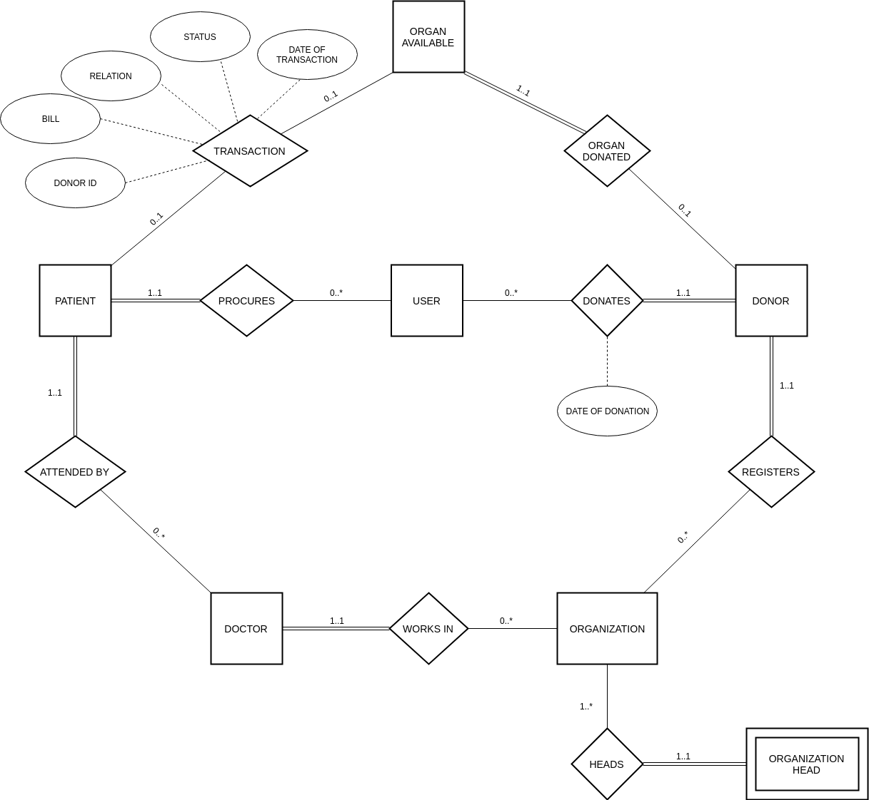

An **Entity–relationship model (ER model)** describes the structure of a database with the help of a diagram, which is known as an Entity Relationship Diagram (ER Diagram). An ER model is a design or blueprint of a database that can later be implemented as a database. The main components of ER model are **entity set and relationship set.**

**ER TO RELATIONAL MAPPING:**

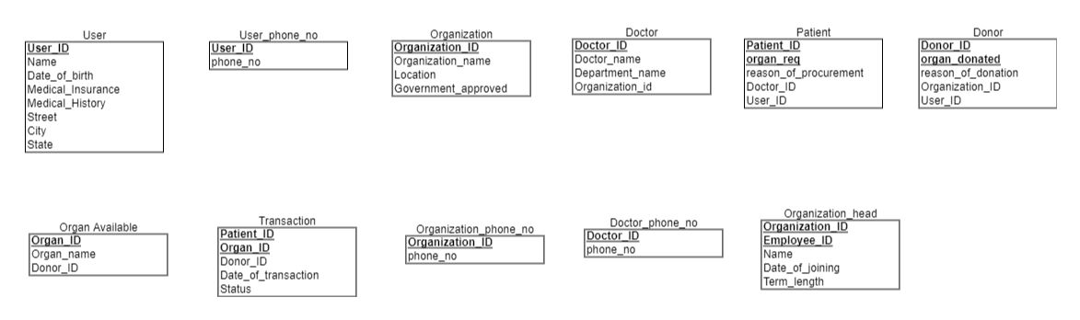

A **schema diagram** can display only some aspects of a schema like the name of record type, data type, and constraints. Other aspects can’t be specified through the schema diagram.

**Tables and their Functional Dependencies :-**

1) User(User_ID, Name, Date _of_birth, Medical_Insurance,

Medical_History, Street, City, State)

FD={User_ID → Name, Date _of_birth, Medical Insurance,

Medical History, Street, City, State}

2) User_phone_no(User_ID, phone_no)

FD={User_ID -> phone_no}

{User_ID} is foreign key constraint

3) Patient(Patient_ID, organ_req, reason_of_procurement, Doctor_ID,

User_ID)

FD={Patient_ID, organ_req -> reason_of_procurement,

Doctor_ID, User_ID}

{User_ID, Doctor_ID} are foreign key constraints

4) Donor(Donor_ID, organ_donated, reason_of_donation,

Organization_ID, User_ID)

FD={Donor_ID, organ_donated -> reason_of_donation,

Organization_ID, User_ID}

{User_ID, Organization_ID} are foreign key constraints

5) Organ Available(Organ_ID,Organ_name, Donor_ID)

FD={Organ_ID -> Organ_name,Donor_ID}

{Donor_ID} is foreign key constraint

6) Transaction(Patient_ID, Organ_ID, Donor_ID, Date_of_transaction,

Status)

FD={Patient_ID, Organ_ID -> Donor_ID,Date_of_transaction,

Status}

{Patient_ID, Donor_ID} are foreign key constraints

7) Organization(Organization_ID, Organization_name, Location,

Government_approved)

FD={Organization_ID -> Organization_name, Location,

Government_approved}

8) Organization_phone_no(Organization_ID, phone_no)

FD={Organization_ID -> phone_no}

{Organization_ID} are foreign key constraints

9) Doctor(Doctor_ID, Doctor_name, Department_name, Organization_id)

FD={Doctor_ID -> Doctor_name, Organization_id}

{Organization_ID} is foreign key constraint

10) Doctor_phone_no(Doctor_ID, phone_no)

FD={Doctor_ID -> phone_no}

{Doctor_ID} is foreign key constraint

11) Organization_head(Organization_ID, Employee_ID, Name,

Date_of_joining, Term_length)

FD={Organization_ID, Employee_ID -> Name, Date_of_joining,

Term_length}

**MODULES:**

* Login Module: This module is used by the existing admin to login into the website. It takes the username and password as input from the user and compares the data with the database. If the data matches, it takes the user to the home page, else it displays the wrong credential alert to the user.
* Homepage Module: This module is the home page of the user. It has some description about the website and contains buttons to apply all other queries.
* User Module: This module provides functionality to see, update and delete user details.
* Search Module: This module provides functionality to search about entities in the database.
* Add Module: This module provides functionality to add new data to the database.
* Update Module: This module provides functionality to update the data about the entities in the database.
* Remove Module: The module provides functionality to remove particular data from the database.
* Statistics Module: The module provides visualization of data using the matplotlib library of python.

**APPLICATIONS:**

Organ Donation and Procurement Organizations play a pivotal role in today’s medical institutions. Such organizations are responsible for the evaluation and procurement of organs for organ transplantation. These organizations represent the front-line of organ procurement, having direct contact with the hospital and the family of a recently deceased donor. The work of such organizations includes to identify the best candidates for the available organs and to coordinate with the medical institutions to decide on each organ recipient. They are also responsible for educating the public to increase the awareness of and participation in the organ donation process. Also, it keeps track of all transplantation operations carried till date.

The Organ Donation and Procurement Network Management System is a database management system that uses database technology to construct, maintain and manipulate various kinds of data about a person’s donation or procurement of a particular organ. It maintains a comprehensive medical history and other critical information like blood group, age, etc of every person in the database design. In short, it maintains a database containing statistical information regarding network of organ donation and procurement of different countries.

Organ Wastage is a major issue that can only be solved by having a proper database of all Patient and Donors in a well-formed way, that can be processed easily. Records of donor and patients are created when a person donates or procures an organ from a Medical Institution. Records may include the following information :-

1. Personal Information

2. Medical History

3. Medical insurance, if any

4. Allergies to any medicine, if any

5. The need for an organ presently

6. Medical Insurance provided by any private or government insurers.

7. Address